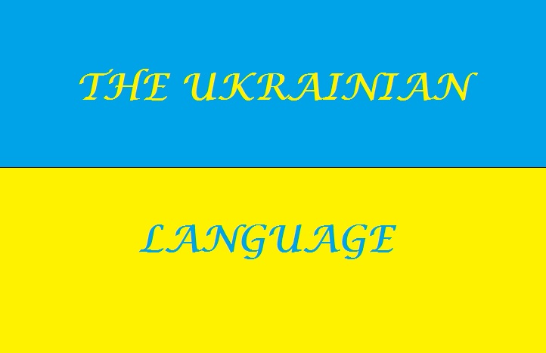
https://ferulang.wordpress.com/2014/09/03/what-do-you-know-about-ukrainian/

6 Amazing Facts about Ukrainian Language
- Ukrainian among Related Languages
Ukrainian is one of the most widely spoken among the Slavic languages. Ukrainian together with Belarusian and Russian belongs to the East branch of the Slavic of languages of the Indo-European language family. The closest languages to Ukrainian are Belarusian (approx. 85 %), Polish (70%) and Russian (62%). This is not surprising considering the fact that Russian, Ukrainian and Belarussian evolved from Old Slavic language used in medieval state of Kyivan Rus’. It is spoken by about 46 million people in Ukraine and in other countries, first of all, neighboring such as Belarus, Poland, Slovakia, Hungary, Romania, Russia, in immigrant communities in Brazil, Canada, Australia, the USA and many other countries. Ukrainian is the official language in Ukraine and first of two principal language of Ukrainians. The second is Russian which is spoken mostly by the south and east population.
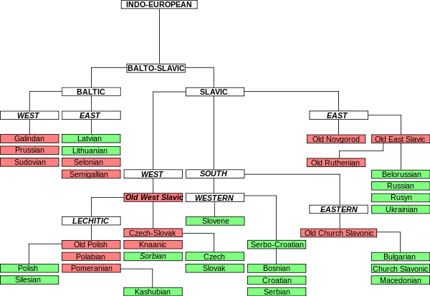

http://www.wikiwand.com/en/Slavic_languages
- History
There is a lot of misunderstandings about where the Ukrainian language comes from. Historical linguists associate its origin with the Old East Slavic and medieval state of Kyivan Rus' which united territories of modern Ukraine, part of Russia and Moldova during 9th-13th centuries. The history of recorded Ukrainian began in 988 when Volodymyr the Great adopted Christianity from the Byzantine Empire. Then the Bible was translated to Old Slavonic, the language used by missionaries to spread Christianity.
While official language was Old Slavonic used by Church people spoke in Old Eastern Slavic from which the development of the languages of East Slavic group, namely Ukrainian, Russian and Belarussian began. Considerable distinguishing of these languages was noticed since 16th century. Then Ukraine went under the rule of Polish-Lithuanian Commonwealth and Ukrainian language suffered considerably from Polish.
- Modern Ukrainian
The first documents which included some words written in Ukrainian can be dated back to the 16th century. The Ukrainian has been in common use since the late 17th century. This period is associated with the establishment of the Cossack Hetmanate and rule of Bohdan Khmelnytsky who fought against Polish domination. The birth of modern literary Ukrainian is associated with publishing in 1798 poem Eneyida written in spoken language by Ivan Kotliarevsky regarded as the founder of modern Ukrainian literature. In the 19th century Ukraine fell under the rule of Russian Empire. Then printing of books in Ukrainian and its usage in schools were prohibited.
The hardest period in the history of Ukrainian is the period of the Soviet Union. Then Ukrainian was considered as forbidden and Russian was declared as an official language of many nations. The official status of Ukrainian was reclaimed after the collapse of the USSR which enabled Ukraine’ declaring of its independence in 1991.

Ukrainian alphabet
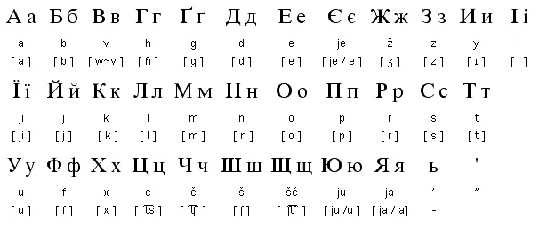
https://katherineaxelsen.wordpress.com/2011/07/30/ukrainian-alphabet/
The modern Ukrainian alphabet (‘azbuka’, 'abetka’, ‘alfavit’) consists of 33 letters. It is based on the Cyrillic script designed by St. Brothers Cyril and Methodius, so Ukrainian is a little bit familiar with Old Church Slavonic this script was used in. The letters Ґ, Є and Ї are unique to Ukrainian. Under Soviet rule the letter Ґ was excluded from the alphabet as “very Ukrainian” which was aimed to make Ukrainian closer to Russian. All vowels may appear in the accented and unaccented position but in unaccented syllables the distinction between such vowels as y and e is neutralized.
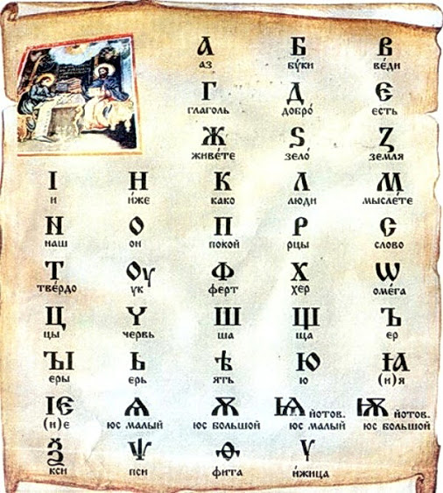
https://plus.google.com/photos/105455646532537279674/albums/6301601338336785473/6301601338451434066?sqi=115158803034870717522&sqsi=187a47fa-7c80-4b62-9db0-93663ca3e5ab&sqi=115158803034870717522&sqsi=187a47fa-7c80-4b62-9db0-93663ca3e5ab
- Grammar
Parts of speech in Ukrainian are declined or conjugated by such common categories as number (singular and plural) and case (7 cases), tense (present, perfect, imperfect, aorist, and pluperfect; last two are archaic). The future tense is created by forms of auxiliary verb to be used in future time and an infinitive verb. Nouns have 3 genders (masculine, feminine and neuter). Ukrainian belongs to fusional languages which states that to create new grammatical, syntactic or semantic meanings it uses morphemes. Words are constructed by morphemes which are meaningful no matter is this a foot or a suffix or ending.
Word compounds are quite rare in Ukrainian but if created they are usually formed by connecting two words with linking vowels: -o-, -e-.
- Dialects
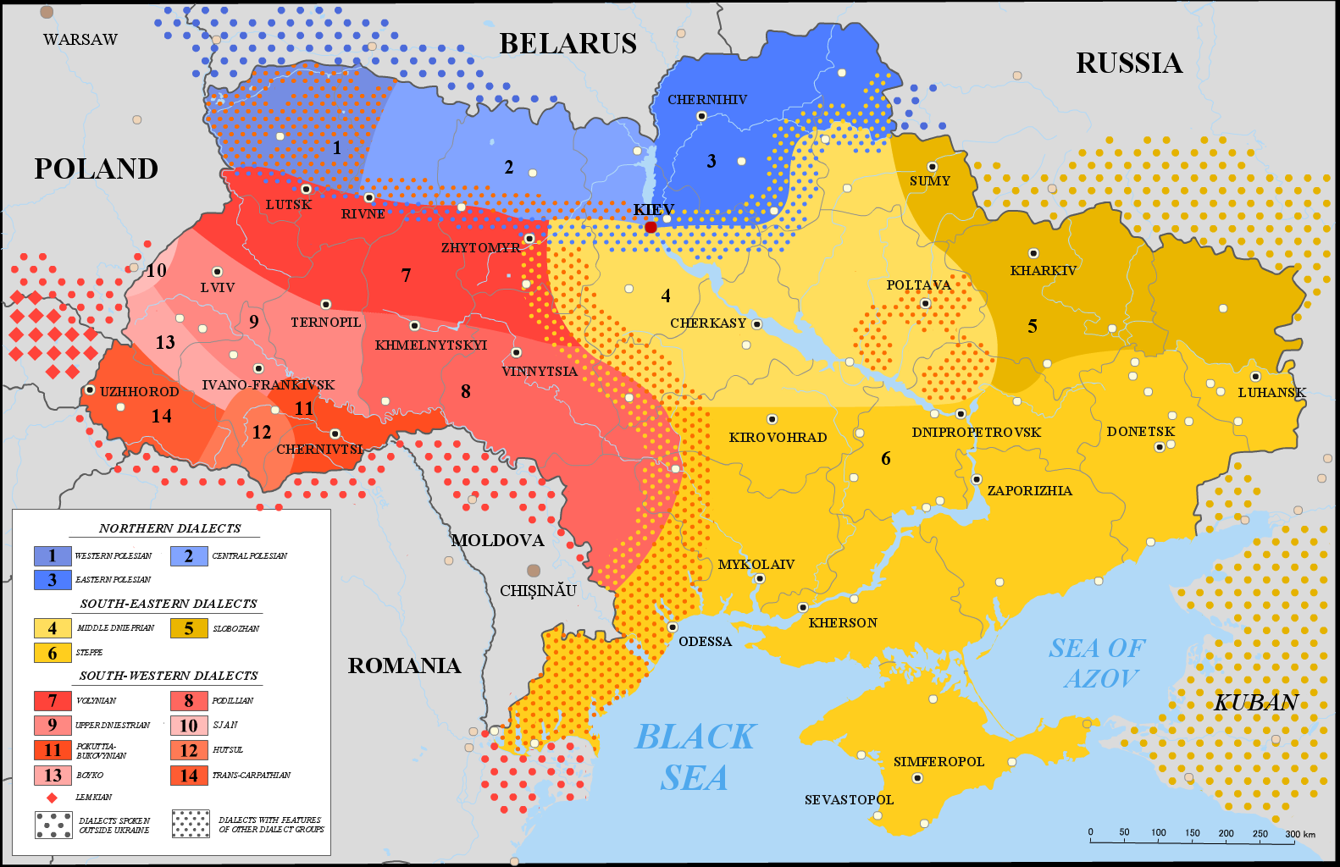
http://wiki.eanswers.com/en/West_Polesian_microlanguage
Within its boundaries Ukrainian is represented by 3 main groups of dialects namely northern, southwestern and southeastern dialects which differ from the others significantly. The modern literary Ukrainian is based mainly on the Poltava-Kyiv dialects of the southeastern group in which Ivan Kotliarevsky’s Eneyida was written.
Nevertheless, Ukrainian a long time was under the repression of the neighbour countries its development resulted in the beautiful language which sounding is often compared with the nightingale’s song.

